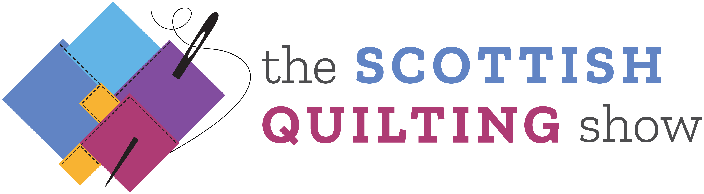

The Quilting Show
Hall 4, SEC, Glasgow, 7-10 March 2019

QUILTING COMPETITION: SCHEDULE

Competition entries are invited for the following classes. Entry is open to anyone except where a restriction is contained within the class schedule. Competitors are advised to read the rules and regulations carefully, ensuring that their entry complies with the requirements of their chosen class.

You may enter more than one class, but we do need your completed entry forms by midnight on Thursday 31st January 2019 at the latest. If you have any queries about entering the competitions – email Jane Bolsover on jane@janebcreatives.co.uk with your question.

Competition Categories Glasgow 2019

Please read the rules in addition to the class categories, NOTE deadline for competition entry is midnight Thursday 31st January 2019

Competition Prizes
The value of the prizes for each category is as follows:
Prize value: Gold Award £350.00
Prize value: Silver Award £100.00
Prize value: Bronze Award £50.00

The judges may award ‘highly commended’ prizes for up to three additional quilts across any category.

All prizes are as stated. No cash alternatives shall be offered.

We strongly recommend that you attend the Award ceremony on Sunday 10th March.

A: Traditional Quilts
Quilts made using traditional pattern or design. Either pieced together and quilted, appliquéd and quilted, wholecloth and quilted, or a combination of all these techniques – quilting by hand or machine.

B: Contemporary Quilts
Quilts based on the traditions of quilt making, but have an original approach. Makers may use non-traditional fabrics, fabric painting, printing, dying and embellishments. These quilts should have an original design and can be hand or machine pieced, or a combination of both.

C: Art Quilts
These quilts are designed as a piece of artwork to be hung on a wall. They maybe pictorial or not, but they must have strong visual impact and be highly executed.

D: Group Quilts
One quilt produced by two or more makers, using any technique.

E: Themed Quilt – Colour of the Isles
Two-dimensional quilts using any technique including mixed media; the finished piece should reflect the theme.

SPONSORS:

