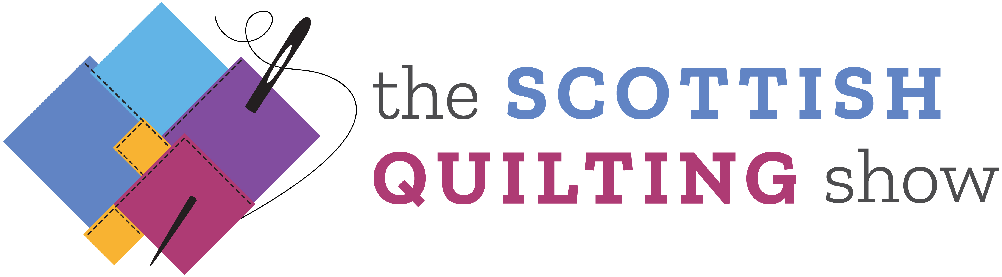

Hall 4, SEC, Glasgow, 5-8 March 2020

QUILTING COMPETITION RULES & REGULATIONS

Definition of a quilt

The structure of a quilt is traditionally three complete layers, but a minimum of two layers is acceptable. Stitch or other elements must hold these layers together.

Entries

1. These competitions are open to all quilters in the British Isles. Quilts entered into this competition should be single sided and not previously entered into any other competition.

2. Only one piece maybe entered per category and competitors must complete an entry form for EACH ENTRY by the closing date. All entries must be the bonafide work of the individual or group who has entered.

3. Entrants must acknowledge if their quilt design has been made from a book, magazine, workshop or kit. Please also state if it has been longarm quilted by someone else and ensure that it is entered into the Group Category.

4. Entries must measure no less than 51 x 51 cm (20 x 20 in), and no more than 152.5 x 203com (60 x 80 in); each side of the work must be within these limits. Please ensure accurate dimensions are provided on the entry form.

5. A hanging sleeve of 10cm (4 inches) must be attached to the back of the quilt, unless it features an integral hanging device. Failure to provide this will mean that the quilt cannot be displayed.

6. The decision for the category entered is the responsibility of the maker. Quilts cannot be swapped to another category after the entry form has been processed.

7. We reserve the right to NOT hang work that contains any sharp or dangerous materials, or which, the Organiser’s feel is unsuitable in anyway for display.

8. Please ensure each entry has a label on the back of the quilt to enable us to identify your quilt. Please cover the label on the back with a flap of fabric, to ensure anonymity during the judging process.

9. We endeavour to hang all pieces, which comply with the Rules & Regulations, where we receive an entry form by the due date, but this cannot be guaranteed and the Organisers reserve the right not to display any piece for whatever reason.

10. All competitors will receive acknowledgment of their entry, plus a Competitors badge, which gives free access to the show on all 4 days. Please go to the Organisers’ office on arrival, to collect your badge.

Dates and Fees

1. Entry forms must be received by Friday 24 January 2020. Entries may not be accepted if they arrive after this date.

2. You must enclose a photograph, sketch or layout of your finished, or planned piece with the entry form, to help with the identification of your entry.

3. Each entry form must also be accompanied by the correct registration fee of £15.00. THERE WILL BE NO REFUNDS. Please note, there is an additional £10.00 charge, should you require your quilt to be returned by Special Delivery or courier.

Packaging your Quilt

1. Packaging the quilt is the maker’s responsibility. For POSTAL quilts we advise rolling your quilt face out around a cardboard tube, and covering with bubble wrap and brown paper, for protection. For HAND delivery please use minimal packaging, which you will be asked to take away with you.

2. Attach a ‘From’ label to your parcel, to enable us to identify your entry, also stating the category that you are entering (A, B, C, D, E or F). Make sure your labels are clear as to whom the parcel is ‘To’ and ‘From’. Please use BLOCK CAPITALS. Please also enclose a SELF-ADDRESSED RETURN LABLE for your package.

Delivery of your Quilt

Please choose one of the following options to get your quilt to us:

Option 1: POST OR COURIER
Deadline for the delivery of all quilts to the following address is Tuesday 25 February 2020.

Quilting Competition 2020
ICHF Events
Dominic House
Seaton Road
Highcliffe
Dorset
BH23 5WH

Email: janetw@ichf.co.uk
Email: mshunter@icloud.com

The cost of the postage will depend on the courier or service that you choose.

Option 2: DELIVER BY HAND
Delivery to this address is Tuesday 3 March 2020, between the hours of 11am and 4pm.

Margo Hunter
Hall 4.A Entrance
SEC
Exhibition Way
Glasgow
G3 8YW

Tel: 07531 195219

Judging and Award Ceremony

1. Judging will take place on Wednesday 4 March 2020 on the set up day of the show. There will be no access to the area on Wednesday, whilst the judging is taking place. The results will be available from Thursday morning and published on the ICHF website. The show opening times are as follows: Thursday, Friday and Sunday 10am – 4pm (Saturday 4.30pm).

2. The judges’ decision is final and no correspondence will be entered into.

3. The prizes will be accepted as stated. There are no cash alternatives.

4. All winners will be announced at the show and prizes presented in the Lecture Theatre at 2.30pm on Sunday 8 March 2020. If winners are not in attendance, the prizes will be dispatched to them. We strongly recommend that you attend the Award Ceremony on Sunday 8 March.

Security
While reasonable care will be taken with the security of all exhibits, the Organisers’ will not be held responsible for any loss or damage to exhibits, equipment or personal effects.

Insurance
Insurance is the responsibility of the quilter. We cannot insure quilts on your behalf.

Intellectual Property Rights
By entering competitions and allowing work to be shown at The Quilting show, PLEASE BE AWARE that photographs or copies maybe taken by any person or visitor, and realise that your designs/work may be reproduced, but you will not hold ICHF or its employees’ liable in any way should this occur.

Photography
Please note the Organisers will be taking photographs of the competition entries at this event. These photographs may be used within magazines, newspapers, online and Social Media and to promote future events.

Removal of Exhibits from show
All exhibits must be removed at the stated time and NOT before. Collection can commence from 5pm – 6pm Sunday 8 March 2020. Please be aware of this rule when organising your travel plans. Competitors’ badges must be worn as proof of ID to enable you to collect your quilt from the show. The Organisers’ reserve the right to remove any exhibit not taken by 7pm on Sunday 8 March 2020.

PLEASE NOTE: If you have arranged for your quilt to be returned by post, then you may not change your mind and collect it in person, or nominate anyone else to do so after the show.

