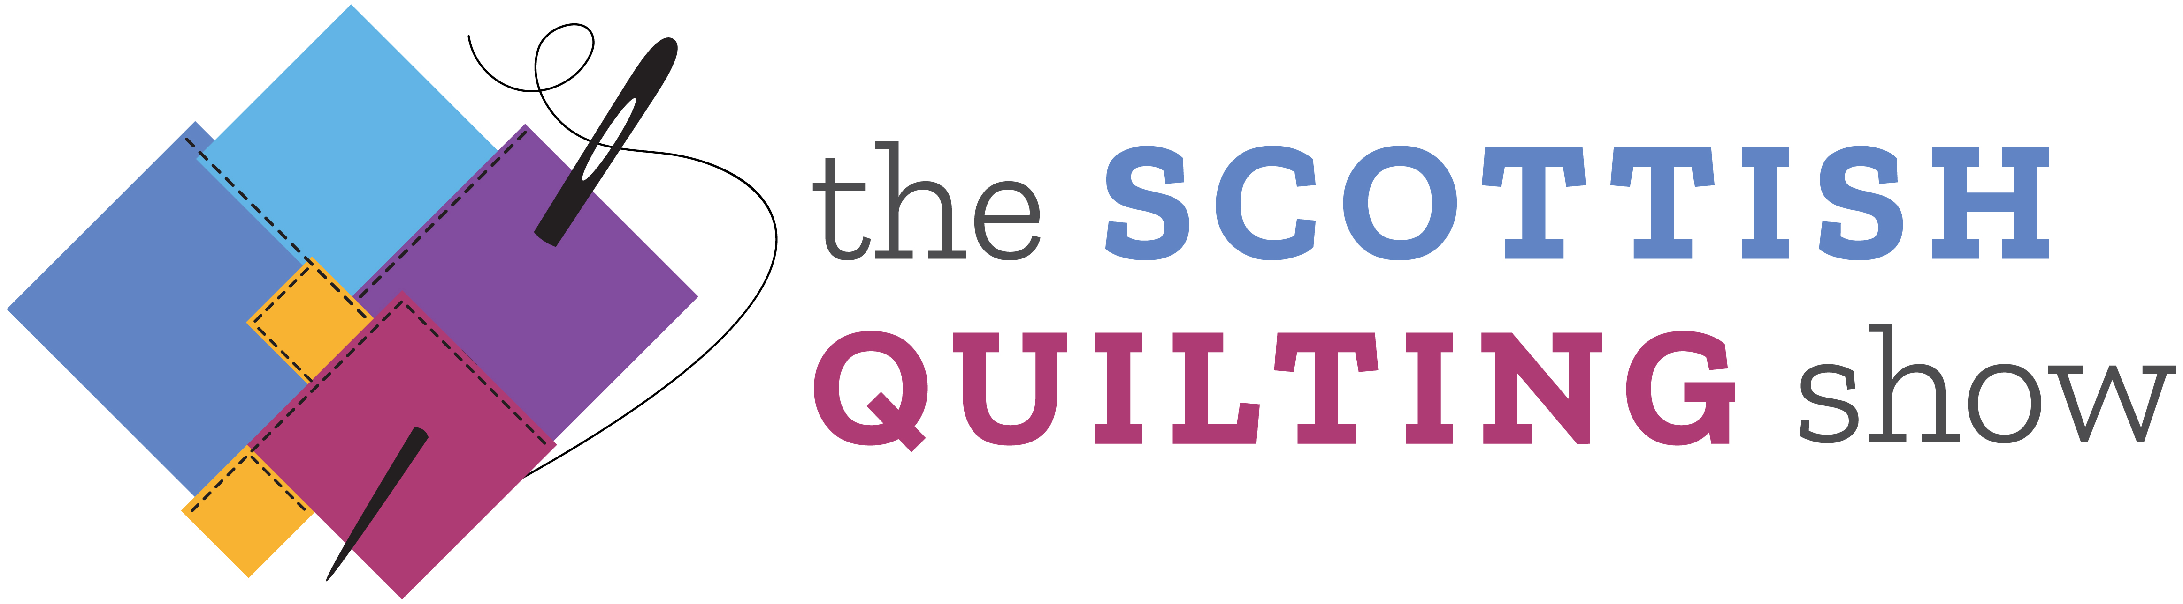

The Scottish Quilting Show
Hall 4, SEC, Glasgow, 3-6 March 2022

QUILTING COMPETITION: ENTRY FORM

Please print out this form and complete one form for each category that you wish to enter. If you are unable to print out the form, please call +44 (0) 1425 272711 for a hard copy to be sent by post.

Send the completed form/s to ICHF (details are at the end of this form), along with the following:

- a photograph of the completed or planned quilt
- the £15.00 entrance fee

Please complete clearly in BLOCK CAPITALS and return by the deadline date (see website for details)

Contact details

Name:
Address:
(including post code)
Country:
Telephone (home):
Telephone (mobile):
Email:

Category

Class you wish to enter -
Competitor’s number:
(for official use)
Category:
Identify by its letter.
One entry only per form

Size
The size of your quilt (in CENTIMETRES); please ensure your quilt fits the minimum and maximum dimensions stated in the rules.

Height in cm:
Width in cm:

Delivering your quilt to us
Please indicate below which of the following methods you are delivering your quilt to us:

 | Delivery Address | Deadline  Delivery Date | Indicate below the relevant delivery method
a) | By post to ICHF Events  (see Rules & Regulations for the address) | See website
b) | Hand delivery to Scotstoun Community Centre  (see Rules & Regulations for times and address) | See website

The return of your quilt
Please indicate below how you would like your quilt returned:

 | Collect From: | Deadline  Delivery Date | Indicate below the relevant collection method
a) | Collect from the SEC, Glasgow | Sun of the show between 5pm  & 6pm ONLY
b) | Return by Special Delivery or courier | Within one month of the show*

* Please Note: There is an extra £10.00 charge for option B - special delivery/courier

Judges’ comments

Would you like to receive a copy of the judges’ comments? | YES or NO  (please delete as appropriate)

Payment

I enclose my cheque for £15.00, made payable to ICHF Ltd | YES or NO  (please delete as appropriate)
I enclose my cheque for £25.00, made payable to ICHF Ltd (£15.00 entry + £10.00 for return postage) | YES or NO  (please delete as appropriate)
Alternatively, please call the Ticket Hotline on 01425 277988 to make card payments | YES or NO  (please delete as appropriate)

Quilt Signage

Makers Name:
Title of Quilt:
Category entered:
Please let us know the inspiration for your quilt (50 words maximum):

Send your entry form, photograph and entrance fee to:

The Scottish Quilting Show Competition
ICHF Ltd,
Dominic House,
Seaton Road,
Highcliffe,
Dorset
BH23 5HW

You can also email your entry form and digital image to: info@ichf.co.uk and payment can be made over the telephone on 01425 277988

Deadline: see website

Please provide details below if you would like us to keep you up to date with special offers and news by email and/or SMS from ICHF:

Email address:
Mobile phone number:

   Please keep me up to date with special offers and news from carefully selected companies. Your personal details will not be shared with those companies – we send the emails and you can unsubscribe at any time. By submitting your information you agree to our Privacy Policy available at: https://www.ichfevents.co.uk/privacy

