# EXHIBITOR TICKET REFERRAL SCHEME

## FAQs

**What is on offer?**We’re offering you the chance to connect with your customers by helping to sell show tickets and as a result save money on the cost of your stand! Earn a substantial 10% commission on all show tickets you refer across the remainder of the 2018 show calendar as part of our new affiliate ticket program.

More detail:

Exhibitors are encouraged to sign up to this scheme and promote the ICHF series of events to their own customer base, either through social media channels, web promotions or other communication methods.

**How does it work?**You’ll have your own unique code from which all of your ticket sales can be tracked.  So you just need to promote show tickets to your client base and commission will start to accumulate according to the number of ticket sales you have generated.  
  
The offer applies to all our show brands, including The Creative Craft Show, The Country Craft Shows and Cake international.

More detail:

Visitors should be directed to our show websites where they will be able to buy tickets. At the point of purchasing tickets, they will be asked to enter your unique code in the discount box (see below) which will entitle them to their early bird discount. This will then allow us to track referrals and calculate your commission.

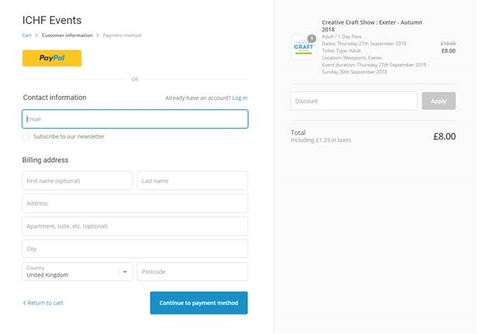

**What’s in it for me?**You’ll get 10% commission on every ticket sold, which will be credited against your stand invoice account. The more sales you promote, the cheaper exhibiting becomes …simple!

More detail:

Commission will be calculated at the end of the following periods:

The first period covers 1st July – 30th September 2018; commission will be calculated and credited to your account during the first 10 days of October.

The second period covers 1st October – 30th November 2018; (after our last show of the year) and commission will be calculated and credited to your account during the first 10 days of December.

Calculated commissions will be based on the price inclusive of VAT. For example if 1,000 tickets are referred at an average sale value of £12.00 (including VAT), the calculated credit to your account will be 10% x £12,000 (incl. VAT) i.e. a credit of £1,000 + £200 VAT will be applied to your account.

Credit notes will display your referral earnings against each show in that period.

Credits will be valid for a period of 12 months from the date of creation and can only be applied against invoices raised after the date of the credit note.

Deposits and invoices for stand bookings before these dates should be paid under normal payment terms.

Which shows does this apply to?

Below is confirmation of the 2018 series of events for which the scheme relates.



Will this be repeated for the 2019 show series?

The Autumn 2018 show series will be a trial period, but we are keen to roll this scheme out again for future years.

**How do I sign up?**If you’d like to take us up on this exclusive offer in partnership with ICHF Events, just reply to this email lindat@ichf.co.uk or call the sales office on 01425 272711 and speak to Linda Tuck.  
  
We look forward to hearing from you  
  
The ICHF Team