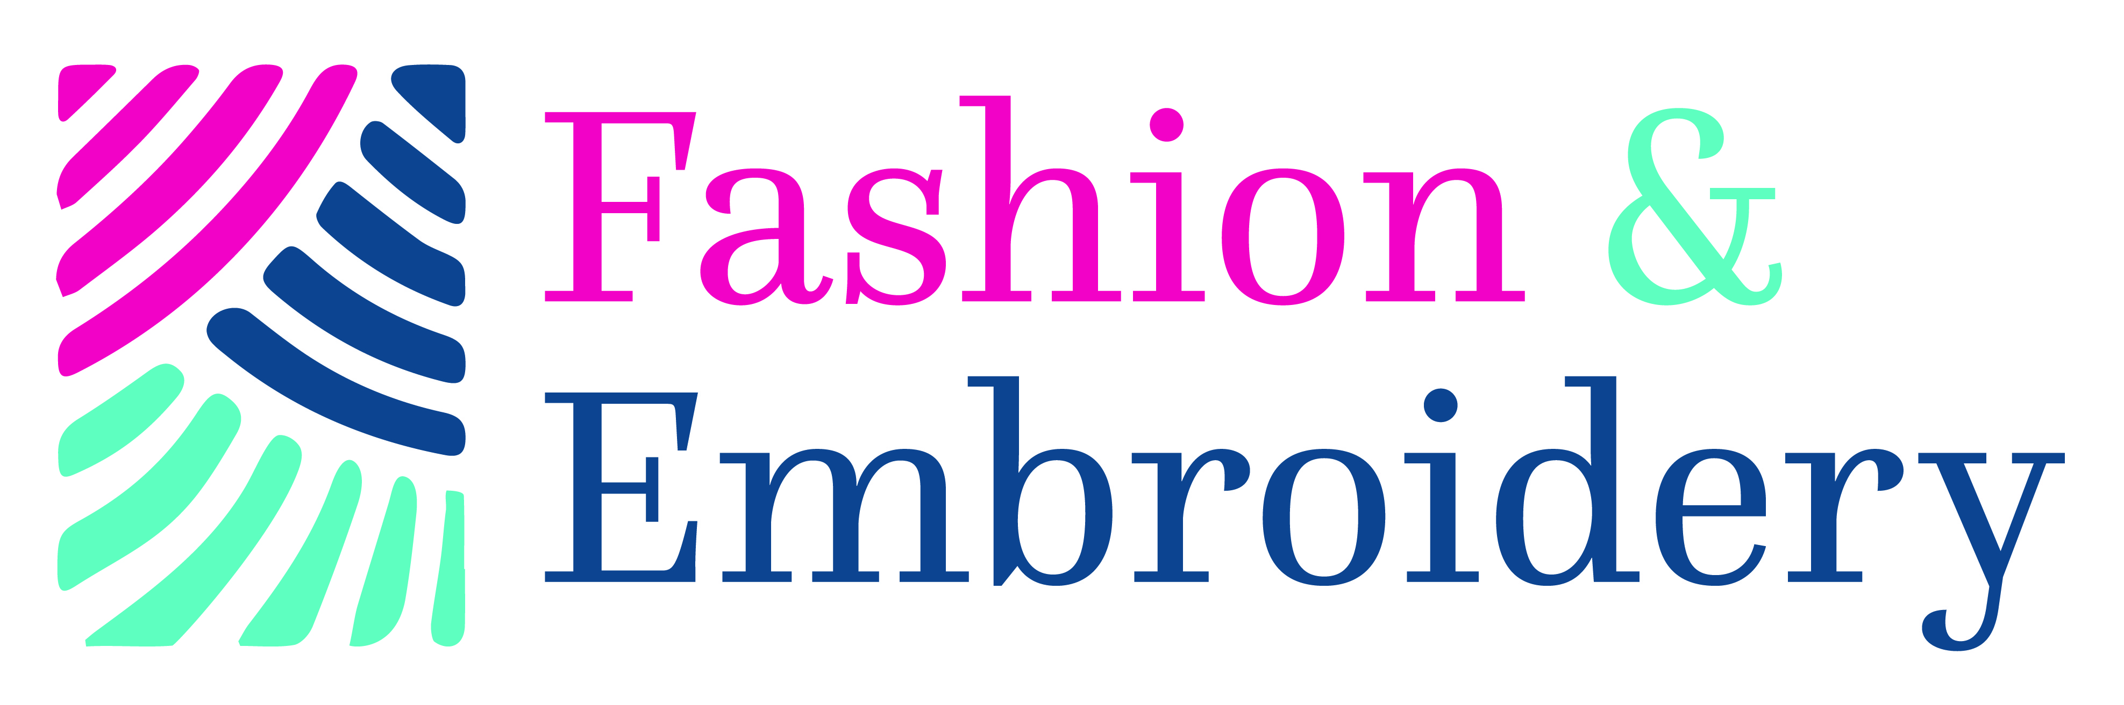

Madeira/Stitch Embroidery Competition
NEC, Birmingham, 18-21 March 2021

GLIMPSES OF THE ISLANDS: ENTRY FORM

Please print out this form and complete one form for each category that you wish to enter. If you are unable to print out the form, please call +44 (0) 1425 272711 for a hard copy to be sent by post.

Send the completed form/s to ICHF (details are at the end of this form), along with the following:

- a photograph of the completed or planned embroidery
- the £15.00 entrance fee

Please complete clearly in BLOCK CAPITALS and return by Friday 29 January 2021

Contact details

Name:
Address:
(including post code)
County:
Telephone (home):
Telephone (mobile):
Email:

Category

Class you wish to enter -
Competitor’s number:
(for official use)
Category:
Identify by its number.
One entry only per form

Size
The approximate size of your finished piece of work (in CENTIMETRES); there is no restriction on the size, but please ensure you state the frame size of any pieces that are framed, rather than the finished stitched size.

Height in cm:
Width in cm:

Delivering your embroidery to us
Please indicate below which of the following methods you are delivering your piece to us:

 | Delivery Address | Deadline  Delivery Date | Indicate below the relevant delivery method
a) | Hand delivery to ICHF Events office  (see Rules & Regulations for times and address) | Mon 1st to Friday 12th February between 10:00  and 16:30 ONLY Mon-Fri
b) | By post to ICHF Events office  (see Rules & Regulations for the address) | Friday 12 th February

The return of your embroidery
Please indicate below how you would like your embroidery returned:

 | Collect From: | Deadline  Delivery Date | Indicate below the relevant collection method
a) | Collect from the ICHF Events office  (see Rules & Regulations for the address) | Mon 29th March and Friday 9th April between 10:00  and 16:30 ONLY Mon-Fri
b) | Return by Special Delivery or courier | Within one month of the show

Payment

I enclose my cheque for £15.00, made payable to ICHF Ltd | YES or NO  (please delete as appropriate)
Alternatively, please call the Ticket Hotline on 01425 277988 to make card payments | YES or NO  (please delete as appropriate)

Embroidery Signage

Makers Name:
Title of Piece:
Category entered:
Please let us know the inspiration for your embroidered piece (50 words maximum):
List of any Madeira Threads used in your work:

Send your entry form, photograph and entrance fee to:

The Madeira/Stitch Embroidery Competition
ICHF Ltd,
Dominic House,
Seaton Road,
Highcliffe,
Dorset
BH23 5HW

You can also email your entry form and digital image to: info@ichf.co.uk and payment can be made over the telephone on 01425 277988

Deadline: Friday 29th January 2021

Please provide details below if you would like us to keep you up to date with special offers and news by email and/or SMS from ICHF: https://www.ichfevents.co.uk/privacy/

Email address:
Mobile phone number:

   Please keep me up to date with special offers and news from carefully selected companies. Your personal details will not be shared with those companies – we send the emails and you can unsubscribe at any time. By submitting your information you agree to our Privacy Policy available at: www.ti-media.com/privacy/

