

**DO’S & DON’T’S OF STAND DESIGN**

1. Plan out your space

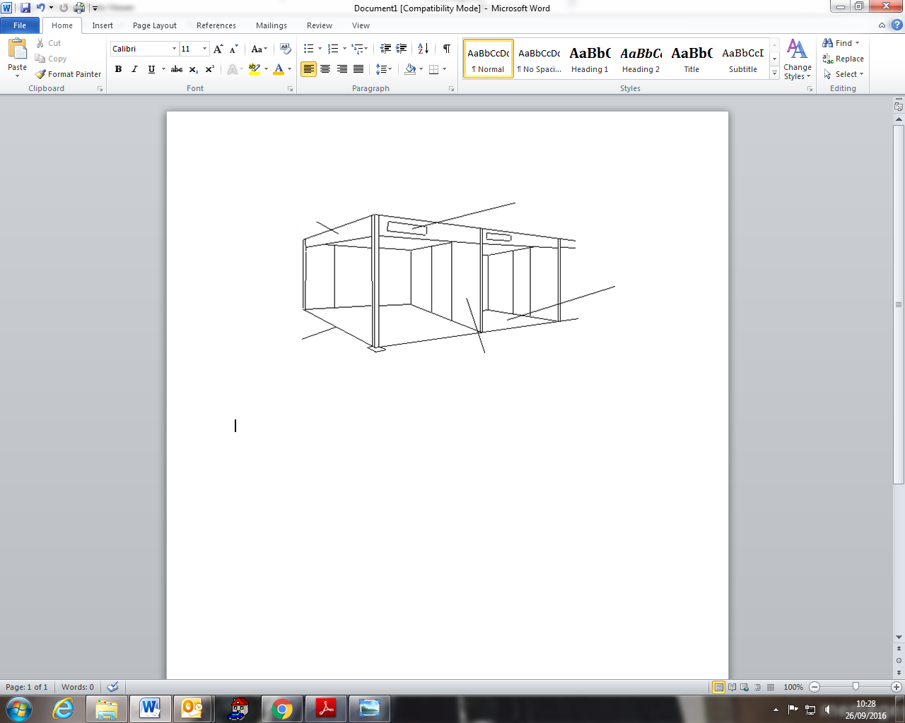

Name board: black letters on white background. No additional company logos or signage permitted. Provided by ICHF.

Painted wooden fascia

Flooring is wooden

Example of a corner stand, two sides open

2.7 metre high walls are white painted

The line drawing shows you the basic structure of the stand. Plan out the space in advance with room to create displays, store products and entice people in.

✶

2. Give your stand the wow factor

Exhibitors should aim to create a beautiful, festive and luxury looking display to fit with the Country Homes & Interiors brand (see the moodboard at the end of this document). We encourage our exhibitors to be imaginative, original and creative with their displays to create the best possible platform to promote and sell their products. Think of your stand as your shop window.

Walls are white painted wood

Walls are white painted wood

✶

3. Make the walls and floors look attractive

The walls of the shell scheme will be wooden and painted plain white and can be used to display any of the following: Fabric covering, panels, company name or logo, large printed or framed images, wall stickers or boards, mirrors or frames, hooks to display items. The floor is brown wood for functionality but you may want to think about carpeting or well-secured rugs.

✶

4. Make your displays exciting

Furniture, rails and storage can all be used to create a unique and high-end look.

* Use wooden rails as opposed to chrome.
* House your products in cabinets, counters, dressers, display units as opposed to a trestle table with a cloth covering.
* Be imaginative with ladders, crates, trays, tubs and baskets.
* Keep excess stock out of sight and stored neatly.

To order lighting or electrics – please see order sheet.

✶

5. Go the extra mile with finishing touches

It’s Christmas and visitors are here to shop! Finishing touches can make a stand look even more enticing. Make an effort with mirrors, flowers/plants, rugs, fairy lights, garlands, Christmas decorations.

✶

What not to do…

* No chrome rails
* No over cluttered stands
* No ‘S’ hooks
* No bare trestle tables on display
* No handwritten signs
* No sale signs
* No boxes of stock on show

✶

Use this moodboard for inspiration

This is the moodboard the style team at Country Homes & Interiors is using to create the overall look and feel of the show. We hope you’ll feel inspired to recreate it on your stand in your own unique way.

✶

 





Real trees & foliage • Berry red • Forest green

• Slate grey • Rustic wood